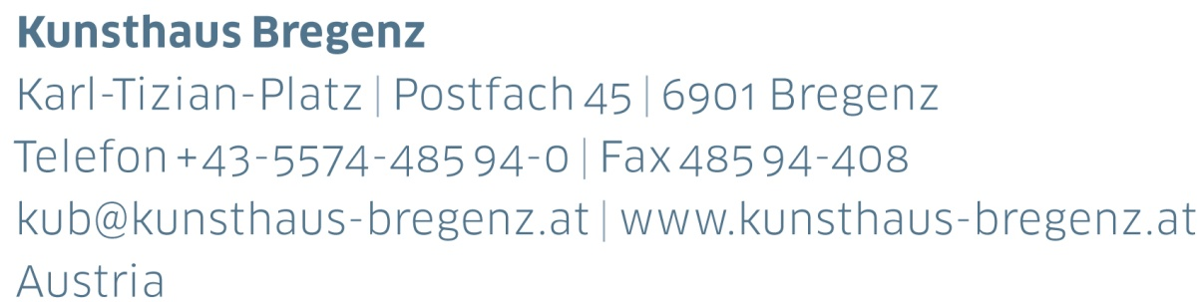

Bregenz, July 2018

Opening and artist talk with Curator Rudolf Sagmeister

Dear Sir or Madam,

We look forward to welcoming you to the press conference for

KUB Billboards

Lili Reynaud Dewar

Oops, I think I may have lost my lighter somewhere on the ground... Could someone please be so kind to come here and help me find it?

26 | 07 — 21 | 10 | 2018

Thursday, July 26, 2018, 7 p.m.  
Kunsthaus Bregenz.

From July 26, Lili Reynaud Dewar (*1975 in La Rochelle, France) will be curating the KUB Billboards.

Lili Reynaud Dewar will be present.

Best regards,



Martina Feurstein

Head of Communication

Kunsthaus Bregenz



Registration

Opening and Artist Talk of

KUB Billboards

Lili Reynaud Dewar

Oops, I think I may have lost my lighter somewhere on the ground... Could someone please be so kind to come here and help me find it?

26 | 07 — 21 | 10 | 2018

Thursday, July 26, 2018, 7 p.m.  
Kunsthaus Bregenz

* I will attend
* I cannot attend
* Please send me the press release

to the following email address

|  |  |
| --- | --- |
| First name, last name |  |
| Name of publication |  |
| Street address |  |
| Phone |  |
| E-Mail |  |

Please register by July 25, 2018

at Kunsthaus Bregenz

P +43-5574-485 94-410

m.feurstein@kunsthaus-bregenz.at

Press photos for download

www.kunsthaus-bregenz.at



KUB Billboards | Press Release

Lili Reynaud Dewar

Oops, I think I may have lost my lighter somewhere on the ground... Could someone please be so kind to come here and help me find it?

26 | 07 — 21 | 10 | 2018

Seestraße, Bregenz

Opening and artist talk with Curator Rudolf Sagmeister

Thursday, July 26, 2018, 7 p.m.

Press photos for download

www.kunsthaus-bregenz.at

KUB 2018

Billboards

The billboards along Bregenz’s Seestrasse, the town’s busiest throughfare, are a fixture of Kunsthaus Bregenz’s program. During 2018, they will be completely in female hands — four young artists have been invited to each show a series of seven images across this public space.

Kosovo artist Flaka Haliti was followed in May by Alicia Frankovich (New Zealand). Lili Reynaud Dewar (France) continues this series in July. By the end of the year Maeve Brennan will present her work, which is a search of the origins of caring and nurturing in geology and archaeology, and also the value of objects.

The Billboards, in juxtaposition to the large-scale solo exhibitions at Kunsthaus Bregenz, ensure that alternative perceptions, new types of imagery, and current issues are also addressed and made accessible to a wide public.

Flaka Haliti | born in 1982 in Pristina, Kosovo

15 | 02 – 22 | 04 | 2018

Alicia Frankovich | born in 1980 in Tauranga, New Zealand

03 | 05 – 15 | 07 | 2018

Lili Reynaud Dewar | born in 1975 in La Rochelle, France

26 | 07 – 21 | 10 | 2018

Maeve Brennan | born in 1990 in London, UK

08 | 11 | 2018 – 20 | 01 | 2019

KUB Billboards

Lili Reynaud Dewar

Oops, I think I may have lost my lighter somewhere on the ground... Could someone please be so kind to come here and help me find it?

Lili Reynaud Dewar (born 1975 in La Rochelle, France) tells stories of feelings and obstacles in her videos, performances, and sculptures. The French artist explores boundaries and creates spaces in which the weaknesses and strengths of the individual can be experienced. What experiences are part of life in a world in which the private and the public are constantly mixing? What boundaries are insurmountable—historically, socially, economically, or biologically—and how can they be avoided nonetheless?

The French artists work for the KUB Billboards is a series of black-and-white photographs that critically and humorously depict the topics of nudity as a taboo, as well as the female body and its commercialization in today’s consumer culture.

In Bregenz, the naked woman on Reynaud Dewars Billboards asks the passing cars for help: “Oops, I think I may have lost my lighter somewhere on the ground... Could someone please be so kind to come here and help me find it?” Who is helping her?

Lili Reynaud Dewar (*1975 in La Rochelle, France) lives and works in Grenoble, France. In 2013 she was awarded the *Prix Fondation Ricard*.

Solo shows include Palais de Tokyo, Paris (2012/2014); the Outpost in Norwich (2014); New Museum, New York (2014); Kunstverein Hamburg (2016); CAM, Saint Louis (2016); K11, Shanghai (2016); Museion Bozen (2017); Wiels, Brussels (2017) and Atelier Hermès, Seoul (2018). She has participated in several group shows and Biennales at Lyon Biennale (2007/2013); Marrakech Biennale (2014); 2nd Cafam Biennale in Beijing (2014); 56th Biennale di Venezia (2015). She has held performances and screenings at the Calder Foundation, New York (2012); the Serpentine Cinema, London (2012); Centre Pompidou, Paris (2014); Villa Medici, Rome (2017) and the Tate Modern, London (2017) just to name a few.

Partners and Sponsors

Kunsthaus Bregenz would like to thank its partners

for their generous financial support and the cultural commitment that accompanies it.

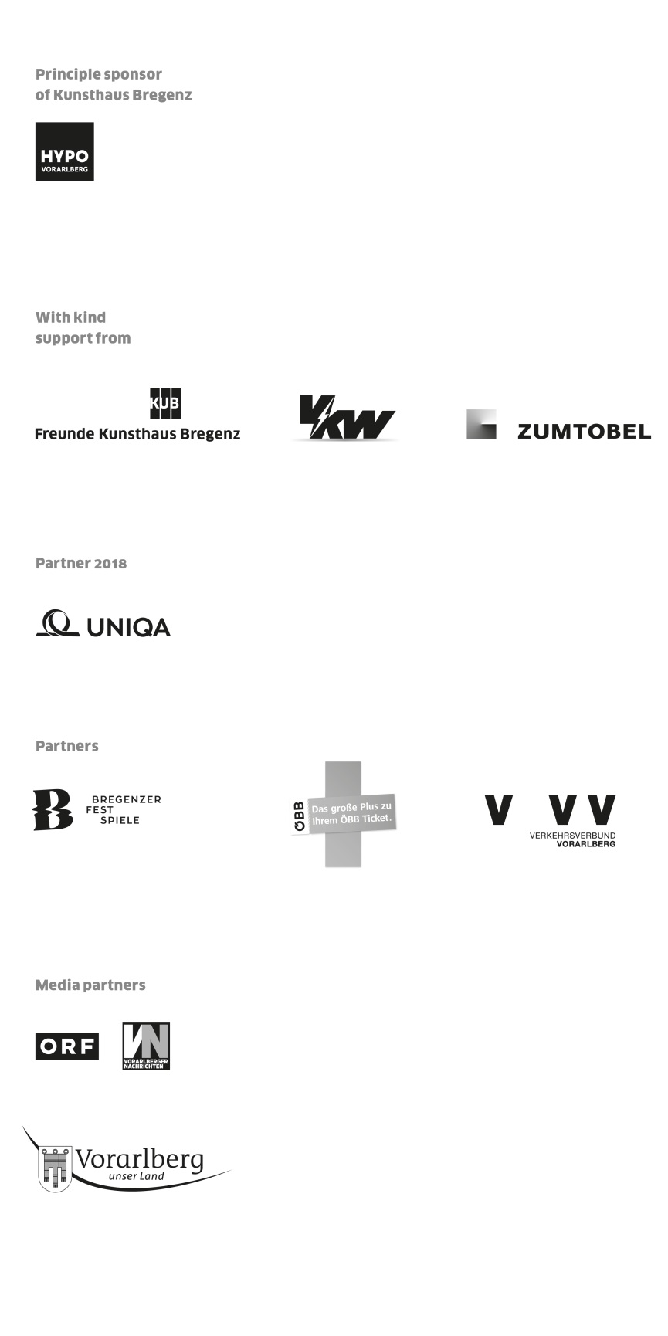



Director

Thomas D. Trummer

Curator

Rudolf Sagmeister

Exhibition Management  
Stefan Wagner | ext. -413

s.wagner@kunsthaus-bregenz.at

Development | Sponsoring

Lisa Hann | ext. -437

l.hann@kunsthaus-bregenz.at

Communication

Martina Feurstein | ext. -410

m.feurstein@kunsthaus-bregenz.at

Art Education

Mareile Halbritter | ext. -417

m.halbritter@kunsthaus-bregenz.at

Visitor Service | Events

Barbara Straub | ext. -415

b.straub@kunsthaus-bregenz.at

Publications

Katrin Wiethege | ext. -411

k.wiethege@kunsthaus-bregenz.at

Artist’s Editions

Rudolf Sagmeister, Katrin Wiethege

Edition Sales

Caroline Schneider-Dürr | ext. -444

c.schneider@kunsthaus-bregenz.at

Opening Hours

Tuesday to Sunday 10 a.m. – 6 p.m.

Thursday, 10 a.m. – 8 p.m.

Ticket Office | ext. -433  
#kunsthausbregenz