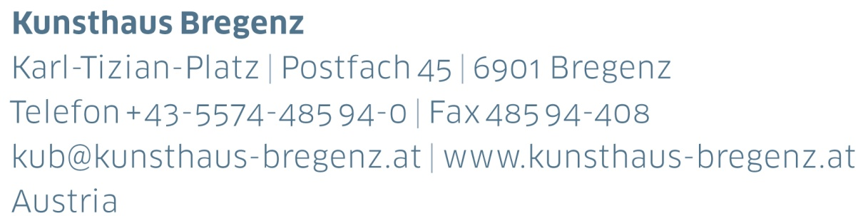

KUB 2024.02 | Press Release
Anne Imhof
08 | 06 — 22 | 09 | 2024

Press Conference
Thursday, June 6, 2024, at 11 am

Opening
Friday, June 7, 2024, at 7 pm

Press photos available for download at
www.kunsthaus-bregenz.at/en/press/anne-imhof

Change in 2024 Program
The Anne Imhof exhibition is being extended until September 22, 2024. This will in turn lead to a postponement in the 2024 exhibition program: the
Tarek Atoui exhibition will open on Friday, October 11, 2024, and run until Sunday, January 12, 2025.

KUB 2024.01
Günter Brus
17 | 02 – 20 | 05 | 2024

KUB 2024.02
Anne Imhof
08 | 06 – 22 | 09 | 2024

KUB 2024.03
Tarek Atoui
12 | 10 | 2024 – 12 | 01 | 2025

Anne Imhof is one of the most important contemporary artists of our time. She was honored with the prestigious Golden Lion at the 2017 Venice Biennale, and she has presented monographic exhibitions of her work at renowned institutions worldwide. Solo exhibitions at MMK in Frankfurt am Main, Tate Modern in London, the Stedelijk Museum Amsterdam, and the Palais de Tokyo in Paris are testaments to her exceptional oeuvre. Imhof’s signature artistic expression is rooted in performance pieces, where casts of androgynous figures navigate the space with a captivating blend of impassive poise and elaborate choreography within an immersive audio-visual experience. This dynamic interplay, underscored by the inclusion of ubiquitous and iconic elements of fashion, photography, and an amalgamation of subculture and popular culture, creates an atmosphere reminiscent of post-apocalyptic isolation.

Within the austere confines of Kunsthaus Bregenz, Anne Imhof ushers in a compelling transformation. In this enigmatic creation, a paradox unfolds, taking the shape of both a barricade and a proscenium.

For the KUB exhibition, Imhof will focus on painting and sculpture, which form the crux of her artistic practice, mirroring the fluid evolution of her performative works. The human figure now assumes an allegorical presence, offering a heightened sense of Imhof’s trademark exploration of the human condition.

Biography
Anne Imhof

Anne Imhof (b. 1978, Giessen) is a German performance and media artist. She completed her studies at the Städelschule in Frankfurt am Main in 2012. For the 57th Venice Biennale in 2017, she designed the German Pavilion and received the Golden Lion for her work Faust. This was followed by solo exhibitions at Tate Modern in London in 2019, the Palais de Tokyo in Paris in 2021, and her first solo exhibition in the Netherlands at the Stedelijk Museum Amsterdam in 2022, titled Youth. Imhof lives and works in Berlin.

Partners and Sponsors
Kunsthaus Bregenz is grateful to its partners for their generous financial support and their ongoing commitment to culture.

