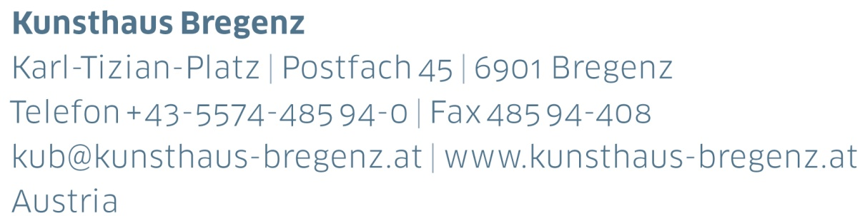

KUB 2021.03 | Press Release
Anri Sala
17 | 07 — 10 | 10 | 2021

Press Conference
Thursday, July 15, 2021, 11 am

Extended Opening
Friday, July 16, 2021, 3 pm to 8 pm

Press photographs for download
www.kunsthaus-bregenz.at

I don’t know what art is, but in my eyes, making art should be a possibility to scratch where it doesn’t itch.

Anri Sala

The 2021 summer exhibition is dedicated to Anri Sala. Originally planned for 2020, the exhibition has been postponed for a year. It is taking place concurrently with the Bregenz Festival, which Kunsthaus Bregenz is collabo-rating with in staging the world premiere of the opera Wind by Alexander Moosbrugger in 2021, as well as hosting festival concerts.

Musical phenomena play a major role in Anri Sala’s work. His transformative, time-based works develop from a dense network of relations between sound, image, and architecture. A recurring medium in the exhibition is film. In contrast to conventional cinema, Sala does not employ a strict narrative or even actors, it is rather musical pieces that become the real protagonists in the works. The cine-matic results from the musical and not, as is customary, vice versa, enabling visitors to immerse themselves in a both visual and acoustic experience of the space.

Kunsthaus Bregenz in its atmospheric presence and dis-tinctive acoustics offers the perfect resonance body for Anri Sala’s art, which always incorporates the exhibition space. For the artist, it is not simply a case of reacting to a given space, but rather about creating the conditions for the various works to be able to relate to one another and the audience.

Recent and entirely new works will be on view in the exhibition at Kunsthaus Bregenz. A record player, floating freely in an abandoned space capsule, a subtle alternating between the architecture’s contours being sharp or blurred, a garden snail slowly moving along a viola bow, a vintage wallpaper-printing roller whose metal pattern is translated into spectral sounds. All of these are elements and imagery that Anri Sala will be employing in engendering creative shifts and to probe existing interpretive relations.

Biography
Anri Sala

Anri Sala (born in 1974 in Tirana, Albania) studied in Tirana, Paris, and Tourcoing. He has been awarded numerous prizes, including the Vincent Award (2014).

Solo exhibitions have included ones at Centro Botín, Santander (2019–2020), Castello di Rivoli, Turin (2019), Museo Tamayo, Mexico City (2017), New Museum, New York (2016), Haus der Kunst, Munich (2015), Centre Pompidou, Paris (2012), and Serpentine Gallery, London (2011).

Sala has participated in many group exhibitions and biennales such as 57th Biennale di Venezia (2017), as France’s representative at the 55th Biennale di Venezia (2013), dOCUMENTA (13) (2012), the 29th Bienal de São Paulo (2010), the 2nd Moscow Biennale of Contemporary Art (2007), and the 4th Berlin Biennale (2006). He has already been exhibited at Kunsthaus Bregenz in the group exhibition Remind... in 2003.
He is showing an installation within the Buffalo Bayou Park Cistern, Houston, until December 2021. Anri Sala lives and works in Berlin.

“In my work it’s never about the music per se, but rather what music goes through: the traces and sediments, scars and remains that a question leaves on the body of music through its passing.”

Anri Sala

KUB Billboards
Anri Sala
17 | 07 – 10 | 10 | 2021

As in many of Anri Sala’s works time is the fundamental subject of the six images featuring on the KUB Billboards. Originating from an artistic correspondence with the curator Hans Ulrich Obrist, Sala imposes time in the form of fragmented clock faces onto iPhone images taken from the window of a plane. The series not only juxtaposes the seemingly quick snapshot with a fine, almost painterly treatment of the image but it pairs as well, the timeless grandeur of the wide sky with the concreteness of the perpetual ticking of the clock.
KUB Publication
Anri Sala

In his videos and installations Anri Sala interweaves music, in its immaterial as well as physical elements, with the spatial. The works hauntingly harmonize with the architecture, creating conceptual worlds from emotion and memory.

In the catalogue, which is being produced as an artist’s book in close collaboration with Anri Sala, Thomas D. Trummer will be expounding on both the concept of the exhibition at Kunsthaus Bregenz and the works, some of which are being shown for the first time. Further essays examine Sala's work from differing perspectives.

Edited by Thomas D. Trummer, Kunsthaus Bregenz
Graphic Design: Studio Quentin Walesch
Essays by Thomas D. Trummer, Ginger Dellenbaugh, Fabienne Liptay, and Bonaventure Soh Bejeng Ndikung
German / English,
approx. 184 pages,
23.5 x 28 cm
Hardcover
Date of publication: September 2021
Price: € 42

KUB Collection Showcase
König-Lebschik Collection
26 | 06 – 29 | 08 | 2021

Thomas König and Erika Lebschik collected original prints by international artists for almost forty years. One of the focuses of the collection is on international and Austrian contemporary art, including well-known artists as Alexander Calder, Marc Chagall, Gunter Damisch, VALIE EXPORT, Bruno Gironcoli, Martha Jungwirth, Maria Lassnig, Joan Miró, Arnulf Rainer, Daniel Spoerri, Antoni Tàpies, and Franz West.

The collection consisting of approximately 3,000 objects was presented as a gift to Kunsthaus Bregenz in 2020. A representative selection of the König-Lebschik Collection is being exhibited at the KUB Collection Showcase in the Post Office building in Bregenz for the first time.

KUB Project 2021
Roman Signer
Installation am Bielbach
Bielerhöhe, Montafon

Installation am Bielbach is a work of art that Roman Signer realized in collaboration with the Kunsthaus Bregenz and illwerke vkw AG on the Bielerhöhe in Montafon at an altitude of over 2000 meters. A stream that flows under a bridge into the lake will be dammed and fed back into the lake as an arched fountain across the path. The stream creates an arch of water that is simultaneously, in turn, a bridge. The absurd manipulation – a water jet becoming an architectural element, and a liquid element a static structure and thus a sculpture – is typical of Signer’s work.

A collaboration between Kunsthaus Bregenz and illwerke vkw AG

Biografie
Roman Signer (* 1938, in Appenzell, Switzerland) is a sculptor, draftsman, action artist, conceptual artist, and filmmaker. He lives and works in St. Gallen. Roman Signer has been recognized as one of the most significant European contemporary artists working today, since participating in documenta 8 in Kassel (1987), Skulptur Projekte Münster (1997), as well as the Venice Biennial (1999).

Partners and Sponsors
Kunsthaus Bregenz is grateful to its partners for their generous financial support and their ongoing commitment to culture.

