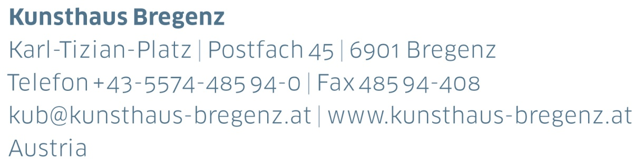
KUB 2022.01 | Press Release
Dora Budor
19 | 03 — 26 | 06 | 2022

Press Conference
Thursday, March 17, 2022, 11 am

Extended Opening
Friday, March 18, 2022, 5 pm to 8 pm

Press photographs for download
www.kunsthaus-bregenz.at

Dora Budor’s exhibition at KUB introduces a scopic crisis
to Peter Zumthor’s building. In her work, the Croatian-born artist regards buildings and institutions as tectonic, infra-structural, and gendered systems which she attempts to make understandable beyond the immediately perceivable. Budor is attempting to pathologize the visual sensuality
of the KUB building through a series of interventions, internalizing external structures and making concealed sonic phenomena audible in the form of acoustic resonances. The inner is inverted outwardly and the previously out of sight is brought to the surface.

There is a manhole on the side of the north-eastern wall of Kunsthaus Bregenz which provides access to the squalid underground collector duct that leads around the basement of the entire building. So-called diaphragm walls, a structural necessity, reach to a depth of 26 meters and are surrounded by groundwater flowing from the nearby Pfänder mountain into Lake Constance. On the first floor of KUB Budor is presenting freestanding sculptures of inverted casts of this subterranean crevice against the gallery walls. Its segments measure 29 meters in total, which is the width and length of the excavated pit that hosts the building’s foundations. The wall’s latex surface has captured decades of sediments and deposits. In a continuation of a series of recent works conceived meta-bolically, the institution digests its own groundwork. The materials which these works are created from originate from the site of the exhibition itself in Bregenz, such as shredded paper from KUB’s administration building or coffee waste from the KUB café bar, as well as from Berlin, where she has spent the last few months conceiving the exhibition.

Budor’s works appeal to all the senses, even air becoming an essential element in them. Quivering sex toys in the emergency staircase set the air vibrating, which emanates from the 28-kilometer-long network of pipes, responsible for the temperature control and ventilation of the building. Circulation becomes a medium in its most impressive form, the air we breathe.

Biography
Dora Budor

Dora Budor (* 1984, Zagreb) is an artist and writer who lives and works in New York. Solo exhibitions at Kunsthaus Bregenz and GAMeC Bergamo are being planned for 2022. Her most recent solo exhibitions were Autoreduction at Progetto, Lecce (2021), I am Gong at Kunsthalle Basel (2019), Benedick, or Else at 80WSE, New York (2018), Ephemerol at Ramiken Crucible (2016), and Spring at Swiss Institute, New York (2015).

Her work has been presented in numerous group exhibitions, including at Migros Museum, Zürich (2021), Schinkel Pavillon, Berlin (2021), Kunst Museum Winterthur (2021), MoMA Warsaw (2020), MO.CO Panacée, Montpellier (2020, 2018), Kunstverein Nürnberg (2019), Kunsthaus Pasquart, Biel (2018), Louisiana Museum of Modern Art, Denmark (2017), Palais de Tokyo, Paris (2017), chi K11 art museum, Shanghai (2017), MOCA Belgrade (2017), Whitney Museum of American Art, New York (2016), Swiss Institute, New York (2016), Museum Fridericianum, Kassel (2015), and Künstlerhaus, Graz (2015). She participated at the Oxygen Biennial Tbilisi (2021), the 58th October Salon of Belgrade Biennale (2021), 2nd Riga International Biennial of Contemporary Art (2020), Geneva Biennale: Sculpture Garden (2020), 16th Istanbul Biennial (2019), 13th Baltic Triennial (2018), Vienna Biennale (2017), and 9th Berlin Biennale (2016).

Budor was a recipient of the Rema Hort Mann Foundation’s Emerging Artist Prize in 2014 and in 2018 the Pollock Krasner Foundation Grant. In 2019, she was awarded a Guggenheim Fellowship in Fine Arts.

Partners and Sponsors
Kunsthaus Bregenz is grateful to its partners for their generous financial support and their ongoing commitment to culture.

