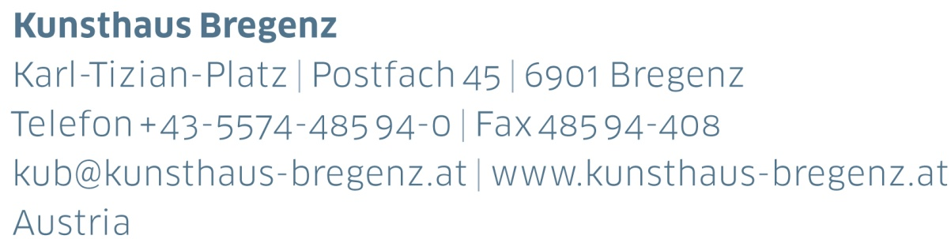

KUB Billboards | Press Release
Alicia Frankovich
After Blue Marble
05 | 05 — 15 | 07 | 2018

Curator
Thomas D. Trummer

Opening and artist talk
Friday, May 4, 2018, 6 pm
Press photos for download
www.kunsthaus-bregenz.at

KUB 2018
Billboards

The billboards along Bregenz’s Seestrasse, the town’s busiest throughfare, are a fixture of Kunsthaus Bregenz’s program. During 2018, they will be completely in female hands — four young artists have been invited to each show a series of seven images across this public space.

The Kosovo artist Flaka Haliti has been presenting her work on the KUB Billboards since February, and is to be followed in May by Alicia Frankovich (New Zealand), and Lili Reynaud Dewar (France) in July — two artists whose works manifest emotional states within spaces and performances. Frankovich addresses the planet earth in the human gaze, whilst Maeve Brennan goes in search of the origins of caring and nurturing in geology and archaeology, and also the value of objects.

The Billboards, in juxtaposition to the large-scale solo exhibitions at Kunsthaus Bregenz, ensure that alternative perceptions, new types of imagery, and current issues are also addressed and made accessible to a wide public.

Flaka Haliti | born in 1982 in Pristina, Kosovo
Alicia Frankovich | born in 1980 in Tauranga, New Zealand
Lili Reynaud Dewar | born in 1975 in La Rochelle, France
Maeve Brennan | born in 1990 in London

Specific dates and details concerning the KUB Billboards 2018 will be published in due course.

KUB Billboards
Alicia Frankovich
After Blue Marble
05 | 05 — 15 | 07 | 2018
Seestraße, Bregenz

During 2018, four young female artists are being invited to present a series of imagery across the seven billboards along Seestraße in Bregenz. After Flaka Haliti Alicia Frankovich (born in 1980 in Tauranga, New Zealand) will present her work.

»Blue Marble was a perceived image of the entirety of our earth — a photograph taken by astronauts on Apollo 17 in 1972. It remains one of the most ubiquitous images of earth. Conversely in light of being situated amidst the anthropocene, as geophilosopher and poet Daniel Falb assert we are in an epoch that can never be visualised with one single image or view. I will take a series of ›portraits‹ taken inside of Earth, using the spherical image we know from images from space, but instead building or imaging worlds within our planet out of a process of engagement with micro worlds within it — a spectrum of non-human living and active entities. Macro photographs of interior biological topographies and non-human surfaces that map specific material entanglements of humans and non-humans. These interior spaces become inversions: surfaces of forms exploring the resonances between micro-processes and macro-ecologies. Artificial hormones and antibiotics become fluid continents; the microscope becomes a telescope.«

Alicia Frankovich on Blue Marble

Alicia Frankovich (New Zealand, 1980) obtained a Bachelor of Visual Arts in sculpture at Auckland University of Technology in 2002. Her work is made up of performance, performance-based videos, short films and sculpture. She puts bodies into situations where they play out relations, often testing social conventions and behaviours.

Partners and Sponsors
Kunsthaus Bregenz would like to thank its partners
for their generous financial support and the cultural commitment that accompanies it.

Alicia Frankovich would like to thank the Centre for Advanced Microscopy (CAM) and the Australian Microscopy & Microanalysis Research Facility (AMMRF) for access to a Leica DM6000, 100x 1.4 N.A. and Olympus BX41, 100x iris 0.6-1.30, equipped with a CytoViva Enhanced Darkfield Illuminator, Spot Flex (model 15.2), Spot Advanced version 4.6.

Director
Thomas D. Trummer

Curator
Rudolf Sagmeister

Exhibition Management
Stefan Wagner | ext. -413
s.wagner@kunsthaus-bregenz.at

Marketing | Cooperation
Birgit Albers
b.albers@kunsthaus-bregenz.at

Development | Sponsoring
Lisa Hann | ext. -437
l.hann@kunsthaus-bregenz.at

Press | Online Media
Martina Feurstein | ext. -410
m.feurstein@kunsthaus-bregenz.at

Art Education
Mareile Halbritter | ext. -417
m.halbritter@kunsthaus-bregenz.at

Visitor Service | Events
Barbara Straub | ext. -415
b.straub@kunsthaus-bregenz.at

Publications
Katrin Wiethege | ext. -411
k.wiethege@kunsthaus-bregenz.at

Artist’s Editions
Rudolf Sagmeister, Katrin Wiethege

Edition Sales
Caroline Schneider-Dürr | ext. -444
c.schneider@kunsthaus-bregenz.at

Opening Hours
Tuesday to Sunday 10 am – 6 pm
Thursday 10 am – 8 pm
Ticket Office | ext. -433 | #kunsthausbregenz

