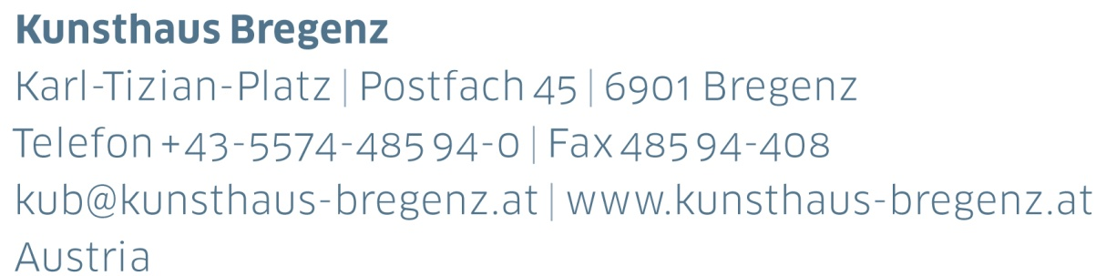

KUB Billboards | Press Release
Flaka Haliti
If Euer There Were Anye
16 | 02 – 22 | 04 | 2018

Curator
Thomas D. Trummer

Opening and artist talk
Thursday, February 15, 2018, 7 pm
Press photos for download
www.kunsthaus-bregenz.at

KUB 2018
Billboards

The billboards along Bregenz’s Seestrasse, the town’s busiest throughfare, are a fixture of Kunsthaus Bregenz’s program. During 2018, they will be completely in female hands — four young artists have been invited to each show a series of seven images across this public space.

The Kosovo artist Flaka Haliti will be presenting work on the KUB Billboards from February 16 to April 22, to be followed by Alicia Frankovich and Lili Reynaud Dewar – two artists who will be displaying imagery of emotional states within interior spaces and performances. Maeve Brennan, born in London in 1990, will be seeking the origins of caring and nurturing in geology and archeology as well as the value of objects.

The Billboards, in juxtaposition to the large-scale solo exhibitions at Kunsthaus Bregenz, ensure that alternative perceptions, new types of imagery, and current issues are also addressed and made accessible to a wide public.

Flaka Haliti | born in 1982 in Pristina, Kosovo
Alicia Frankovich | born in 1980 in Tauranga, New Zealand
Lili Reynaud Dewar | born in 1975 in La Rochelle, France
Maeve Brennan | born in 1990 in London

Specific dates and details concerning the KUB Billboards 2018 will be published in due course.

KUB Billboards
Flaka Haliti
If Euer There Were Anye
16 | 02 – 22 | 04 | 2018
Seestraße, Bregenz

During 2018, four young female artists are being invited to present a series of imagery across the seven billboards along Seestraße in Bregenz. The year will begin with Flaka Haliti, born in Pristina, Kosovo.

In the era of digital imagery, Haliti’s work revolves around such romantic ciphers as clouds, moons, and love letters. And yet Haliti endows her imagery not with gravity, but with a yearning, awkward note. Emotions and messages of love in the digital age are issues she addresses, disguised in the medium of childlike drawing.

Biography
Flaka Haliti

Flaka Haliti lives and works in Munich. She studied at the University of Prishtina and Städelschule in Frankfurt am Main. She is currently working towards her PhD at the Academy of Fine Arts in Vienna.

Haliti’s work has been presented at mumok and Kunsthalle Wien in Vienna, the 6th Biennale in Moscow; Kunsthalle Lingen; Galerie für Zeitgenössische Kunst, Leipzig; National Gallery of Kosovo in Pristina; ZKM in Karlsruhe; Haus der Kulturen der Welt, Berlin; and Portikus in Frankfurt am Main. In 2016 she was awarded the Ars Viva Prize. In 2015, she represented Kosovo at the 56th Venice Biennale.

Partners and Sponsors
Kunsthaus Bregenz would like to thank its partners
for their generous financial support and the cultural commitment that accompanies it.

Director
Thomas D. Trummer

Chief Executive
Werner Döring

Curator
Rudolf Sagmeister

Marketing | Cooperation
Birgit Albers | ext. -413
b.albers@kunsthaus-bregenz.at

Development | Sponsoring
Lisa Hann | ext. -437
l.hann@kunsthaus-bregenz.at

Press | Online Media
Martina Feurstein | ext. -410
m.feurstein@kunsthaus-bregenz.at

Art Education
Mareile Halbritter ext. -417
m.halbritter@kunsthaus-bregenz.at
Barbara Straub ext. -415
b.straub@kunsthaus-bregenz.at

Publications
Katrin Wiethege | ext. -411
k.wiethege@kunsthaus-bregenz.at

Artist’s Editions
Rudolf Sagmeister, Katrin Wiethege,
Samantha-Josephine Kiesel

Edition Sales
Caroline Schneider-Dürr | ext. -444
c.schneider@kunsthaus-bregenz.at

Opening Hours
Tuesday to Sunday 10 am – 6 pm
Thursday 10 am – 8 pm
Ticket Counter | ext. -433

