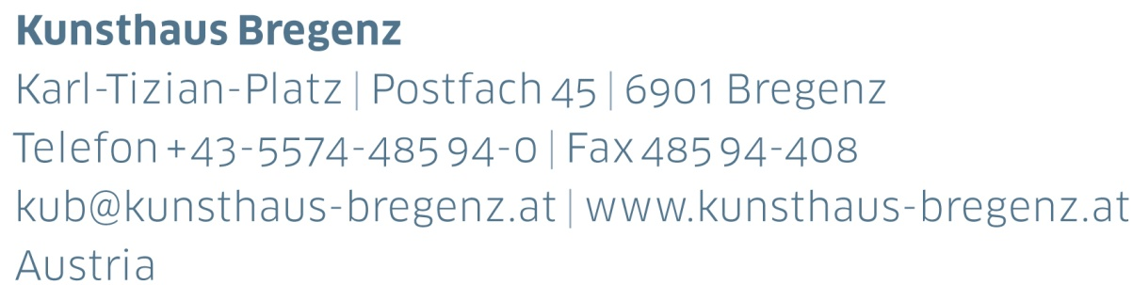

KUB Billboards | Press Release
Simon Fujiwara
Campaign
21 | 04 | 2017 – 07 | 01 | 2018

Curator
Thomas D. Trummer

Press conference
Thursday, April 20, 2017, at 11 am

Opening and film screening of Joanne
with Thomas D. Trummer and Simon Fujiwara
Thursday, April 20, 2017, at 6 pm

KUB Billboards
Simon Fujiwara
Campaign
21 | 04 | 2017 – 07 | 01 | 2018
Seestraße, Bregenz

From April, Simon Fujiwara (*1982) will be curating the KUB Billboards. The British-Japanese artist’s work can be seen as an exploration of the increasing cultural obsession with self-presentation and individuality that due to the influence of new technologies and digital media are ubiquitous for his generation.

In a new special commission Fujiwara conceived of a self-initiated advertising campaign for the Kunsthaus Bregenz that takes place across multiple platforms, from the Kunsthaus Billboards to various online platforms.
Subverting the role of the artist-institution structure, Fujiwara casts himself in the role of PR consultant, reimagining the museum’s public image as material for an exhibition in the form of a publicity campaign that takes place everywhere but in the museum. Expanding on his 2016 project Joanne, Fujiwara employs his former high school art teacher to become the »face« of the Kunsthaus Bregenz media campaign.

Joanne Salley— former beauty queen, artist, champion boxer and victim of a tabloid nudity scandal in Britain—became the subject of an image rebranding campaign by Fujiwara in which he sought to rehabilitate her public image and career as a model after the national media scandal destroyed her career in 2010. Since then Salley and Fujiwara continue their collaborative relationship, utilizing Joanne’s life story
to promote various products including, in this case, the Kunsthaus Bregenz.

Expanding on the principals established by artists including Elaine Sturtevant and Andy Warhol, Fujiwara’s Campaign presents a complex and uneasy relationship between artist and »muse« in which Fujiwara works with his former teacher as a »readymade« in the form of stock image, whose commercially appealing form can be applied to the promotion of endless products.

Opening and film screening of Joanne
with Thomas D. Trummer and Simon Fujiwara
Thursday, April 20, 2017, at 6 pm
Kunsthaus Bregenz

Following the KUB Billboards, the first exhibition in 2018 at Kunsthaus Bregenz will be devoted to Simon Fujiwara.

Partner and Sponsors
Kunsthaus Bregenz would like to thank its partners
for their generous financial support and the cultural commitment that goes along with it.

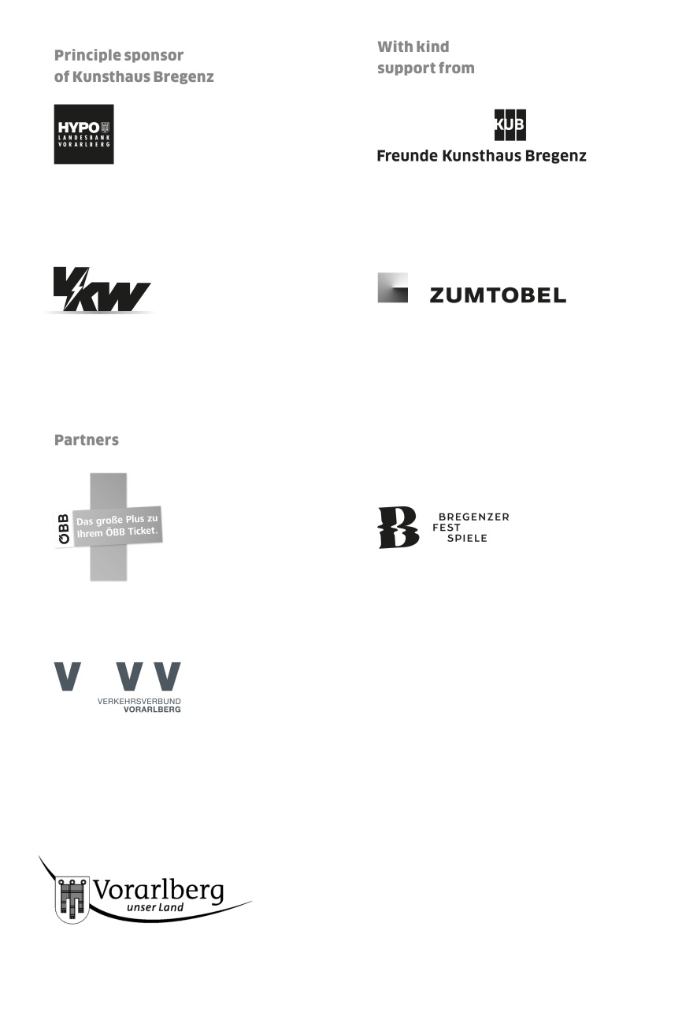

Director
Thomas D. Trummer

Chief Executive
Werner Döring

Curator
Rudolf Sagmeister

Marketing | Cooperation
Birgit Albers | ext. -413
b.albers@kunsthaus-bregenz.at

Development | Sponsorship
Lisa Hann | ext. -437
l.hann@kunsthaus-bregenz.at

Press | Online Media
Martina Feurstein | ext. -410
m.feurstein@kunsthaus-bregenz.at

Art Education
Kirsten Helfrich | ext.-417
k.helfrich@kunsthaus-bregenz.at

Publications | Artist’s Editions
Katrin Wiethege | ext.-411
k.wiethege@kunsthaus-bregenz.at

Sales Editions
Caroline Schneider-Dürr | ext.-444
c.schneider@kunsthaus-bregenz.at

Opening Hours
Tuesday to Sunday 10 am — 6 pm
Thursday 10 am — 8 pm
Ticket Office ext. -433

Summer Opening Hours 2017
July 1 — August 27 | 10 am — 8 pm
Ticket Office ext. -433
Assumption Day, August 15 | 10 am — 8 pm

